**CFA Institute Research Challenge**

**hosted by**

**CFA Society Singapore**

**CHANGI CAPITAL**



The CFA Institute Research Challenge is a global competition that tests the equity research and valuation, investment report writing, and presentation skills of university students. The following report was prepared in compliance with the Official Rules of the CFA Institute Research Challenge, is submitted by a team of university students as part of this annual educational initiative and should not be considered a professional report.

**Disclosures:**

**Ownership and material conflicts of interest**

The author(s), or a member of their household, of this report does not hold a financial interest in the securities of this company.

The author(s), or a member of their household, of this report does not know of the existence of any conflicts of interest that might bias the content or publication of this report.

**Receipt of compensation**

Compensation of the author(s) of this report is not based on investment banking revenue.

**Position as an officer or a director**

The author(s), or a member of their household, does not serve as an officer, director, or advisory board member of the subject company.

**Market making**

The author(s) does not act as a market maker in the subject company’s securities.

**Disclaimer**

The information set forth herein has been obtained or derived from sources generally available to the public and believed by the author(s) to be reliable, but the author(s) does not make any representation or warranty, express or implied, as to its accuracy or completeness. The information is not intended to be used as the basis of any investment decisions by any person or entity. This information does not constitute investment advice, nor is it an offer or a solicitation of an offer to buy or sell any security. This report should not be considered to be a recommendation by any individual affiliated with CFA Society Singapore, CFA Institute, or the CFA Institute Research Challenge with regard to this company’s stock

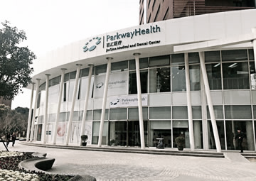

**IHH Healthcare (SGX: Q0F)**

**Sector/Industry: Healthcare Exchange: SGX Recommendation: BUY**

**Current Price: 1.83 SGD Target Price: 2.41 SGD Upside/Downside: + 32%**

**CHANGI CAPITAL**

**29 Jan 2023**

|  |  |
| --- | --- |
| Market Cap | 16.141Bn |
| Shares Outstanding | 8.81Bn |
| LTM P/E (x) | 30.37 |
| LTM EV/EBITDA (x) | 15.34 |
| ROE (%) | 8.03 |
| Free Float | 2.16Bn |
| 52 Week Price Range | 1.68 – 2.16 |
| Dividend Yield (%) annually | 1.01 |

**INVESTMENT SUMMARY**

**FIGURE 1: MARKET DATA**

We issue a BUY recommendation on IHH Healthcare Berhad with a target price of 2.41SGD, presenting a 32% upside within the next year. Our valuation is based on a Discounted Cash Flow Model supported by EV/EBITDA and P/E relative valuation. We see investors under-pricing the stock and the company’s ability to achieve net income growth of 13% CAGR and ROE to increase to 13.2% from 2023-2027F, overlooking its ROE-increasing expansion plan and its long-term strategy of increased differentiation through specialization which allows it to capitalize on growth trends. We therefore believe the stock deserves to be trading at a premium to peers.

**LEADERSHIP IN LABOR MARKET & EQUIPMENT INCREASES PRICING POWER**

IHH leads in the labour market by attracting experienced and reputable medical specialists via the newest equipment and allowing doctors to run their own practice (Figure 3). It is the first mover in key operating regions like Southeast Asia and Turkey to purchase new and advanced medical equipment (Appendix 1), supported by the high receptivity of its affluent customer base. Better treatment outcomes with the newest equipment and highly incentivized doctors differentiate their services from peers, allowing the group to set higher prices. We believe this will continue driving increased profits, allowing the group to obtain even better equipment and specialists, further strengthening their first mover advantage through this positive feedback loop while increasing profits and ROE (Figure 4).

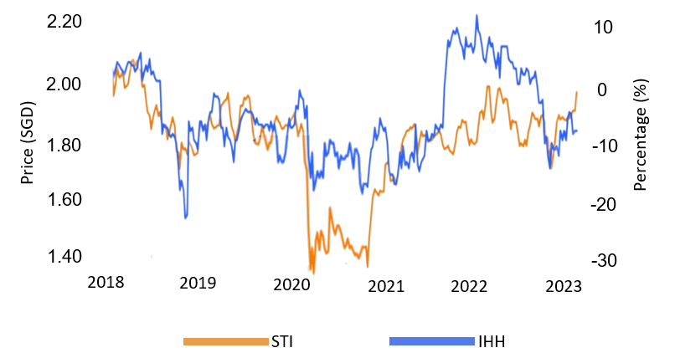

**FIGURE 2: HISTORICAL SHARE PRICE**

*Source: Refinitiv*

*Source: Refinitiv*

**SPECIALIZED POSITIONING TO CAPITALIZE ON POSITIVE DEMOGRAPHIC TRENDS**

Demographic trends indicate a rapid growth in the elderly population, as well as increasing medical tourism to Malaysia and India, which together make up 37.7% of the group’s revenue. We believe IHH is positioning itself to take advantage of these trends by its continued focus on advancing specialist treatment and equipment. As the population continues to age, we expect the strain on public healthcare systems to increase due to the low supply of highly specialized doctors to treat complex illnesses often associated with older people, and the demand for shorter wait times and more personalized services provided by IHH to grow.

Additionally, due to the low cost of treatments in Malaysia and India, medical tourism expenditure into the countries is increasing (Figure 5). As a global player with a history of successfully catering to medical tourists in Singapore, IHH has made medical tourism a core part of its corporate strategy. We believe the company's experience in this area better equips it to capitalize on growing medical tourism in Malaysia and India compared to peers with smaller global footprint. We hence anticipate increased revenue and profits from increasing foreign patient contribution and the aging population.

**ROBUST GROWTH FUELED BY ACQUISITIONS IN EMERGING REGIONS**

We believe IHH will continue to acquire relatively undervalued (Appendix 2), profitable hospitals and clinics in Central & Eastern Europe (CEE) and India while divesting underperforming hospitals acquired under past management. As public healthcare systems are overburdened and advanced private healthcare offerings are not readily available in these regions, IHH can tap into this large, underserved patient pool. As part of their hub-and-spoke strategy, IHH will expand its total addressable market by referring these customers to their advanced tertiary care hospitals (Appendix 3). We therefore anticipate sustained revenue growth through acquisitions of new customer bases and an increase in higher-revenue patients seeking specialized treatment, and continued divestments of underperforming hospitals, driving an increase in ROE.

*Source: ResearchAndMarkets*

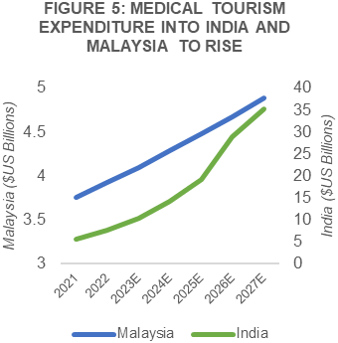

**BUSINESS DESCRIPTION**

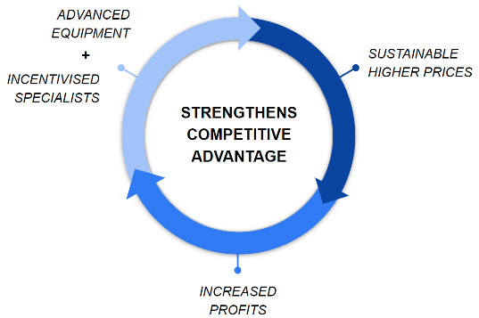

**FIGURE 4: IHH STRENGTHENS ADVANTAGE WITH HIGHER PRICES**

*Source: Team Consensus*

**BUSINESS OVERVIEW**

IHH Healthcare Berhad (IHH) is a leading integrated healthcare provider with 82 hospitals in over 10 countries. Its revenue contributing regions include Singapore, India, Malaysia, Turkey and Central & Eastern Europe (Figure 6). The company offers a comprehensive range of healthcare services, including primary care, secondary care, and tertiary care.

Primary care clinics, which provide basic medical services such as check-ups, vaccinations, and general health consultations. These clinics also act as the first point of contact for patients with non-emergency medical issues.

Secondary care facilities, which include specialty hospitals and other facilities that provide more specialized medical treatments such as diagnostic imaging, laboratory, and inpatient services. These facilities are equipped to handle more complex medical conditions and typically require referral from a primary care physician.

Tertiary care facilities, which provide advanced medical treatments and surgeries, such as cancer treatment, cardiac surgery, and organ transplants. These facilities have the most specialized equipment and highly trained medical professionals and typically require referral from secondary care facilities.

*Source: ResearchAndMarkets, Team Consensus*

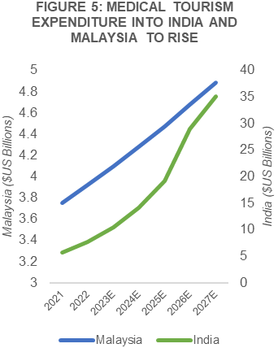

**CORPORATE STRATEGY**

IHH operates under a hub-and-spoke strategy, where a central tertiary specialist hub is the point of referral for multiple smaller hospitals and clinics or "spokes". An example of this would be Acibadem Altunizade, a tertiary care hospital with the capacity to treat referred patients from hospitals in neighbouring regions with complex treatments requiring ongoing specialist care.

This approach allows for a fully integrated pipeline for patients to treat diseases of varying complexities. This strategy enables the sharing of best practices, efficient sharing of patient information and the coordination of medical services across different facilities, which can lead to improved patient outcomes and greater customer satisfaction. It also allows the company to exercise better control over the quality of service, brand reputation and cost across its entire healthcare network.

**REVENUE SHARING MODEL**

Apart from resident anaesthetists, radiologists etc., most medical specialists at IHH operate as third-party contractors, managing their own practice and staff while utilizing the hospital's inpatient care system, operating theatres, and expensive medical equipment. They bring in their own patient base, set their own prices and share revenue with IHH, allowing for a higher income potential that serves as an incentive for renowned medical specialists to join the organization. This structure aligns the interests of both the specialists and IHH.

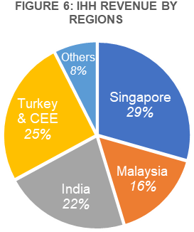

*Source: Company Data*

**INDUSTRY OVERVIEW**

The private healthcare expenditure within IHH’s operating regions is expected to increase over the next few years due to demographic trends such as increased medical tourism and an aging population. At the same time, labour shortages remain an ongoing issue. We expect demand to outstrip supply, and IHH to grow its market share as the industry increases barriers to entry amidst stiffening competition.

**DEMAND OUTLOOK: MEDICAL TOURISM TO IMPROVE REVENUE MIX FOR HOSPITALS**

IHH is projected to benefit from an increase in medical tourism as a beneficiary of its operations in both Singapore, Malaysia. IHH reports that medical tourists account for around 25% revenues from its Singapore operations and about 15% of Malaysian operations. Singapore has historically attracted 500,000 annual medical tourists annually, however that number is projected to decrease as Malaysia offers cheaper prices for standard common procedures like knee-replacement surgeries and heart-bypass surgeries. However, we view IHH’s operations in Singapore to be minimally affected as it continues to develop new specialized procedures and invest in advanced medical facilities. Compared to peer Raffles Medical focusing more on common procedures, we believe that Singapore will continue to be preferred destination for highly specialized treatments requiring expensive

equipment unavailable elsewhere in the region and IHH to benefit from this by attracting price inelastic international patients seeking specialized treatment.

Concurrently, we see the outflow of patients into Malaysia for common treatments benefitting IHH. In terms of revenue contribution from medical tourists in Malaysia, IHH has a higher exposure at 15% compared to its closest competitor KPJ at 7%. IHH differentiates themselves in Malaysia by catering to a more affluent demographic such as medical tourists who normally pay a higher sum for premium private healthcare services compared to less-expensive alternatives offered by KPJ.

**DEMAND OUTLOOK: AGING POPULATION INCREASING HEALTHCARE SPENDING**

A rapidly aging population is expected to significantly increase the demand for private healthcare services in IHH’s operating regions (Figure 7). The elderly are more likely to have chronic health conditions requiring specialized continuous care. While public healthcare systems are expected to bear the brunt of medical treatments from this growing demographic, we expect public healthcare systems to be strained, and wait times to increase (Figure 8). As such, we believe private healthcare providers will continue to generate increased revenue from the elderly who are willing to pay a premium for decreased wait times and more customized treatments.

Still, private healthcare operators may face challenges due to the more limited financial resources of elderly people. Hence, we believe players with initiatives to cater to a wider range of incomes will manage to maintain or grow their market share. This presents a positive outlook for IHH as it is in the process of rolling out a telemedicine platform to cater to a wider income bracket, while maintaining their specialized focus to serve complex chronic illnesses.

**DEMAND OUTLOOK: SHIFTING TREND TOWARDS PREVENTIVE HEALTHCARE**

The increasing prevalence of chronic diseases not just amongst the elderly puts pressure on the healthcare system to provide specialized care, which are normally more costly in equipment and limited in specialist supply. Governments in IHH’s operating regions have increasingly emphasized the need for primary healthcare within their own public healthcare infrastructure and from private healthcare providers (Appendix 4), promoting early intervention before health issues become more complex to reduce the burden on hospitals. As primary care clinics become more involved in preventive care and have tighter control over specialist referrals, we expect there to be increased competition in the primary care market for private healthcare providers. Industry players are likely to see a shifting demand for an increased quality of preventative healthcare. We expect private healthcare players investing in differentiating primary care services through staff and procedures focused on delivering more preventative care to maintain or grow their market share.

*Specialist Outpatient Clinic Patient wait time (days)*

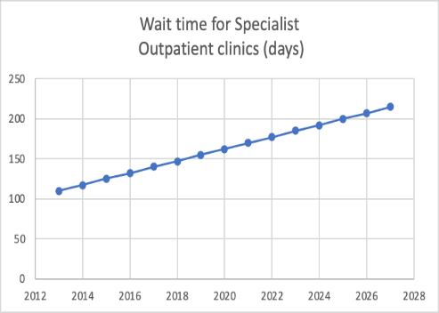

**FIGURE 8: PROJECTED INCREASE IN WAIT TIMES**

Source: NUS School of Public Health Forecast

**SUPPLY OUTLOOK: NURSING SHORTAGE TO IMPROVE**

The extraordinary workload arising from covid-related responsibilities resulted in burnouts and saw an increase nurse attrition rates, worsening the shortage of nurses internationally. However, as covid-19 cases decrease worldwide and hospitals reduce the workload on nurses, we expect the shortage to improve.

**Government policies.** Governments in IHH’s operating regions are implementing policies to increase the number of foreign nurses, such as in Singapore, where the Ministry of Health is working to recognize the contributions of foreign nurses in the process of granting them permanent residency.

Additionally, we expect IHH to resolve their nursing shortage in the next 6 months, as guided by management, through accelerating their hiring process and reducing the workload on nurses by reallocating tasks which do not require a nursing license to general staff, decreasing attrition rates.

**SUPPLY OUTLOOK: MARKET CONSOLIDATION FROM INCREASED FIXED COSTS**

To alleviate the shortage of both doctors and nurses, the need to innovate in technology is increasingly prevalent. The use of automation for non-essential tasks such as scheduling and data entry, and predictive analytics for billing can help reduce administrative workload for healthcare professionals, allowing them to focus on more productive tasks requiring their expertise. This is expected to lead to increased competition between established players in the market operating a large network of hospitals. However, the high fixed costs associated with implementing these technologies, such as the $100 million investment by IHH to accomplish this in the next 3 years, also serve as a barrier to entry for smaller players looking to grow in the market, leading to consolidation among large healthcare groups.

**COMPETITIVE ANALYSIS**

The healthcare industry in IHH’s operating regions is comprised of independent players, large hospital chains and public healthcare systems, operating either primary, secondary, or tertiary healthcare facilities. Barriers to entry include high fixed cost equipment and buildings as well as strict regulation by authorities in the healthcare industry.

Barriers to entry increases from primary to tertiary healthcare as services become more specific and customized to the patient, resulting in less commoditization and greater ability for companies to differentiate their offerings to customers via brand, reputation, and quality of treatments.

# **PUBLIC HEALTHCARE V PRIVATE HEALTHCARE**

In India, public healthcare systems face challenges such as shortage of healthcare professionals, lack of medical goods and poor infrastructure as a result of inadequate funding (Figure 9). In CEE, public healthcare systems continue to experience a brain drain of medical specialists (Appendix 5) and shortage of prescriptions (Figure 10). In India, the situation is further compounded by a high poverty rate, with poor living conditions resulting in a higher prevalence of chronic diseases among this demographic, putting a significant strain on public healthcare.

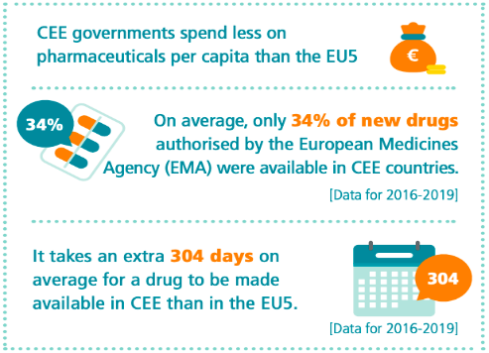

**FIGURE 10: STRUCTURAL DELAY IN PROCUREMENT OF MEDICAL DRUGS WITHIN CEE**

Source: EFPIA



In Singapore and Malaysia, the public healthcare system is relatively well-financed and equipped, however, the heavily subsidized nature of these systems results in long wait times for medical services. Despite recent budget announcements for increased healthcare spending by the government, we anticipate that demand for medical services will continue to outstrip supply, driven by the aging population and the difficulty in increasing the number of specialists (Appendix 6).

We believe IHH will continue maintaining their market share against the public healthcare system in its regions. We expect wait times to persist and anticipate that individuals who can afford to pay a premium for shorter wait times and better quality continue turning to private healthcare alternatives.

**PRIVATE COMPETITION IN SINGAPORE**

IHH is the leading private healthcare provider in Singapore with 52% of the market share in hospital beds. Its closest competitor is Raffles Medical Group (RMG) with a 20% share in beds (Figure 11). While RMG has a notable number of beds, the company’s group operating model hires doctors as employees under payroll. We consider this to be RMG’s weakness against IHH, as affluent patients and medical tourists are generally more price inelastic, seeking out expensive treatments by well-known medical specialists in IHH in favor of the generally cheaper offerings by RMG (Appendix 7).

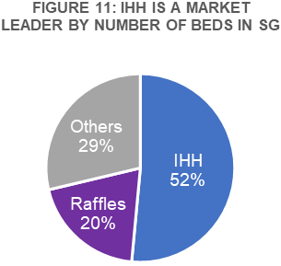

Source: MOH Singapore, JP Morgan

**PRIVATE COMPETITION IN MALAYSIA**

In Malaysia, the competitive landscape is more fragmented than in Singapore, with many private hospitals able to operate independently due to the relatively lower land costs. Nevertheless, IHH and competitor KPJ are the largest private hospital chains in Malaysia, with 15% and 19% of the market share by private bed count respectively. While KPJ controls a larger share of the market by bed count, IHH generates more revenue per inpatient than KPJ (Figure 12). Historically, they have competed for upper-middle class Malaysians. However, IHH is turning its focus to increasingly specialized procedures, catering to higher-revenue medical tourists and patients with complex illnesses. We see this as a positive for IHH against KPJ given the increasing inflow of medical tourists to the country due to relatively lower treatment costs.

**PRIVATE COMPETITION IN EMERGING REGIONS**

In IHH’s fastest growing regions of Turkey & CEE and India, IHH has bought over leading private healthcare providers (Fortis & Global Hospitals in India, Acibadem Group in Turkey). Despite the high level of competition among private hospitals in these regions from players like MLP in Turkey and Apollo Hospitals in India, we believe IHH's competitive advantage is its global scale, which allows the company to diversify its cash flow streams and minimize downside risk in the event of regional economic instability as opposed regional competitors.

Additionally, the company leverages both its experience in running successful healthcare operations in Singapore and Malaysia, as well as cash flows from those operations (Appendix 8), to continuously invest in improving care and treatments in Turkey, CEE, and India, differentiating itself from competitors in these regions.

**FINANCIAL ANALYSIS**

Source: Company Data, JP Morgan

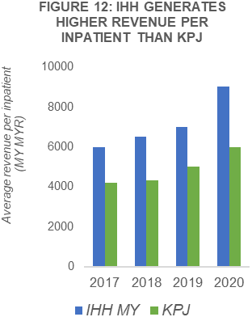

**Sustained and diversified revenue growth**. We expect IHH to continue revenue growth of 10.3% CAGR, stemming from its expansion of its hub-and-spoke strategy as well as the increasing specialization and quality of services it offers. Examining IHH’s revenue in the past 5 years, there was negative revenue growth in 2020 because of restricted movement from the COVID-19 pandemic, resulting in a decrease in discretionary procedures and medical tourism. However, IHH managed to capitalize on the COVID-19 pandemic in 2021, with COVID-19 services contributing more this led to a strong rebound of 27.8% of revenue. Despite revenue from COVID-19 services tapering off, 2022 still saw a 2.8% increase in revenue due to the strong recovery from non-COVID related services.

Source: Company Data, Team Consensus

Going forward, we forecast IHH to enjoy steady growth in revenue from its different operating regions. The **retention of medical specialists** with its revenue sharing model and the **continued renewal of its medical equipment** will continue to **increase the revenue per inpatient admission**, as it has done so since 2017. We expect this to contribute to growth in total revenue for all regions, particularly in Singapore, where it will be the main driver of revenue growth. Hence, we expect a 10% CAGR of revenue from Singapore.

We also foresee **more room for growth in revenues from increased medical tourism**, which currently only accounts for 15% and 8% of revenue from Malaysia and India. IHH’s advanced and reputed medical offerings make its hospitals a prime choice for medical tourists. In Malaysia, IHH’s acquisition of a medical-tourist-focused hospital in 2020, Prince Court Medical Centre (PCMC), will likely further increase foreign patient revenue contribution. For India, according to Research and Markets (2022), there is an expected 35.7% CAGR in the Indian Medical Tourism market from 2021 to 2027, which we foresee IHH being able to capitalize on. Therefore, we anticipate a 9% and 13% CAGR of revenue from Malaysia and India respectively.

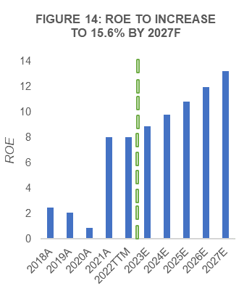

Source: Company Data, Team Consensus

Lastly, the **expansion of IHH’s hub and spoke network** is expected to increase revenue contribution from CEE. IHH’s expansion into Serbia in 2021 coupled with the rebound from COVID-19, saw a 25.6% increase in revenue from CEE YoY in 2021. Looking forward, we expect to see further expansion into Eastern Europe to increase its total addressable market and strengthen its referral network. While we acknowledge that there is likely to be further depreciation of the Lira against the Ringgit, we believe that there will still be positive revenue growth from CEE because 1) IHH has increased non-Lira revenue contribution to 40%, 2) IHH has successfully passed on higher prices to consumers to reflect the decreasing value of Lira. Given that IHH serves an affluent population in CEE, they are less sensitive to price changes, causing patient volumes to remain relatively constant in the last 5 years, despite restricted movement from COVID-19. Hence, we expect an 11% CAGR of revenue from CEE.

To sum up, we expect to see the greatest growth from India, followed by CEE, Singapore and lastly, Malaysia. We expect the revenue contribution from India and CEE to increase to half of total revenue by 2027, allowing IHH to reap more returns from its diversified portfolio of developed and emerging markets. Thus, we forecast a 10.1% CAGR of group revenue from 2023-2027.

# **Cost savings from acquisitions to increase EBITDA margins.** IHH has been able to maintain consistent EBITDA margins of more than 20% since 2017, even with the COVID-19 disruption in 2020. This, in part, can be attributed to cost savings achieved through IHH’s acquisitions to vertically integrate, unlocking economies of scale. To illustrate, when IHH acquired Fortis in FY18, it also acquired Fortis’s landlord, allowing cost savings in service fees of RM220m per annum. These measures have allowed EBITDA margins for India to increase from 10.8% in 2019 to 17.9% in 2021. Going forward, IHH’s global procurement initiatives are also set to achieve RM100m of cost savings in FY22 despite ongoing inflation. Thus, we expect IHH to reap cost savings via an expanded network

# of hospitals, and to continue divesting less profitable or unprofitable assets, increasing EBITDA margins to 25% by 2027.

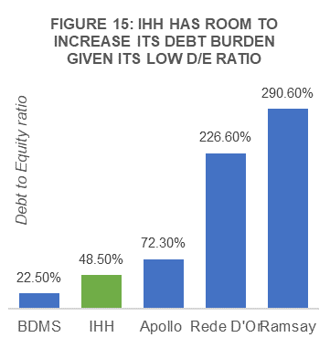

Source: Company Data, Team Consensus

**Strengthening ROE from divestment of unprofitable assets.** Historically, IHH’s ROE has been dragged by its underperforming assets from past acquisitions. Past management’s expansion into mainland China and acquisition of Continental hospitals in India delivered negative returns, causing historical ROE for the group to hover around 4%. The ramp up of new hospitals in mainland China further worsened ROE to 2% from FY18 to FY20. In 2020, new management renewed its strategy, focusing on ROE growth. They minimized losses from unprofitable acquisitions made under past management, divesting China operations along with Continental hospitals in 2021.

Now, management is focused on growing their main chain of hospitals in India, Fortis, which has shown EBITDA margin improvements post restructuring, resulting in an increase of ROE in FY21 to 8%.

Looking forward, IHH’s new management will complete its divestment of IMU by FY23 and we expect them to do the same for other underperforming assets, such as the group’s other hospitals in mainland China. We forecast growing returns from its current operating regions while the company gradually increases their leverage on debt, driving higher ROE for the group to a weighted hospital/healthcare facilities industry average of 13.2% (Appendix 9) by 2027F, based on EBITDA contributions from IHH’s different operating regions.

# **Room to increase debt burden for IHH’s continued expansion and offering of medically advanced services.** IHH has a low debt to equity ratio (Figure 15) compared to its peers in the hospital and healthcare facilities industry with similar market cap. We believe that IHH can further leverage debt to expand its operations and further improve on its service offerings. To illustrate, as guided by management, IHH will be spending USD100mn on technological improvements in the next 2 years. We believe that IHH’s low debt and high interest coverage ratio, as compared to its peers (Figure 16), allows IHH to make such investments to fuel its continued growth. The current ratio is also satisfactory at 1.20x and after divestment of non-core assets, cash balances are expected to increase, further strengthening the company’s balance sheet. We see minimal downside risk in this aspect and do not believe IHH is prone to liquidation.

**VALUATION**

# We reiterate a BUY recommendation on IHH Healthcare with a 12-month target price of SGD 2.41 from our DCF valuation, representing an 32% upside potential from the closing price of SGD 1.83 per share on 29/01/23. We employed the Free Cash Flow to the Firm (FCFF) methodology to our two-stage DCF valuation to derive the intrinsic value of the company. To confirm the validity of our analysis, we compared our DCF valuation against P/E and EV/EBITDA relative valuation models.

Source: Company Data, Team Consensus

**DCF MODEL**

**FIGURE 17: WACC INPUTS**

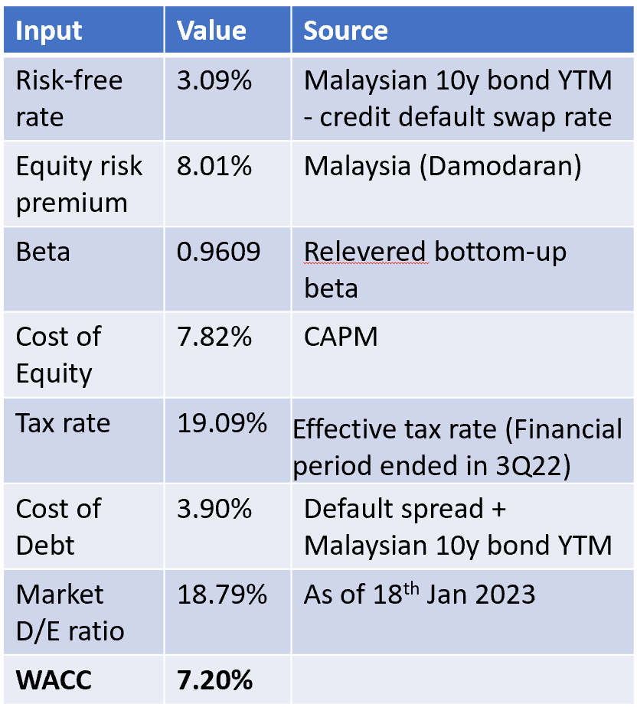

**Revenues:** From our financial analysis, we estimate the growth in group revenue to be 10.1% YoY in our forecast period from 2023 to 2027. This constitutes the following factors: (i) IHH’s revenue growth through profitable acquisitions, (ii) increasing profitable mix of patients with new technologies and development of new procedures and (iii) the growth in demand for healthcare services from medical tourism and ageing population into our DCF analysis. By weighing the forecasted revenue growth rate from each operating region, we arrive at a combined revenue growth rate for IHH.

**Margins:** Based on our financial analysis, we estimate EBITDA margins to grow conservatively at 5.7% CAGR, reaching 25% of revenues by 2027. This is to reflect the cost savings from IHH unlocking economies of scale through its acquisitions, coupled with the divestment of unprofitable assets. The FCFF calculated incorporates the growth in EBITDA margins.

**WACC:** We provide our assumptions used to arrive at our 7.20% WACC (Figure 18). We derived our cost of debt at 3.90% by using the interest coverage ratio of 8.47x (TTM) to determine a synthetic rating and default spread. The spread is then added to the yield to maturity rate of a 10y Malaysian government bond to arrive at the pretax cost of debt. The effective tax rate from the last 12 months of 19.09% is used. The cost of equity of 7.82% is calculated with the CAPM formula, using the implied

equity risk premium for Malaysia, a risk-free rate derived by subtracting the credit default swap rate from the yield-to-maturity (YTM) of 10y Malaysian government bonds, and a re-levered bottom-up beta.

**Terminal growth rate:** We project a conservative terminal growth rate of 2.0% past 2027. We base our rate on our calculated risk-free rate in Figure 18, discounted to reflect decreasing population growth rates in the future.

**SENSITIVITY ANALYSIS**

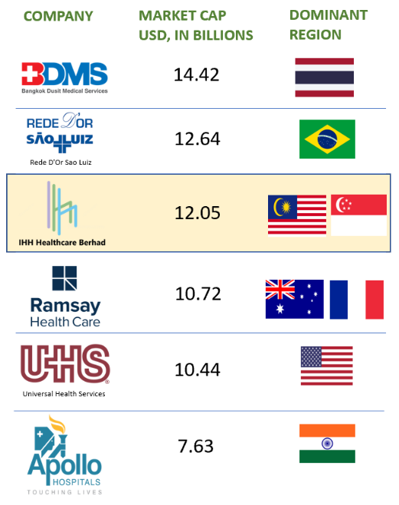

**FIGURE 18: COMPARABLE PEERS USED IN RELATIVE VALUATION**

Source: Bloomberg

To assess the integrity of our target price to changes in the inputs, we incrementally increase/decrease the terminal growth rate and WACC by intervals of 0.5%. We believe that IHH is unlikely to face a downside given the conservative terminal growth rate employed in the DCF valuation. Considering that healthcare expenditure has outpaced GDP growth in the last 5 years, nominal GDP growth due to inflation over time will likely see increases in healthcare expenditure, alluding to a possible greater terminal growth rate and higher potential upside.

**FIGURE 20: IHH TARGET PRICE TO IMPLY UPSIDE IN MOST SCENARIOS**

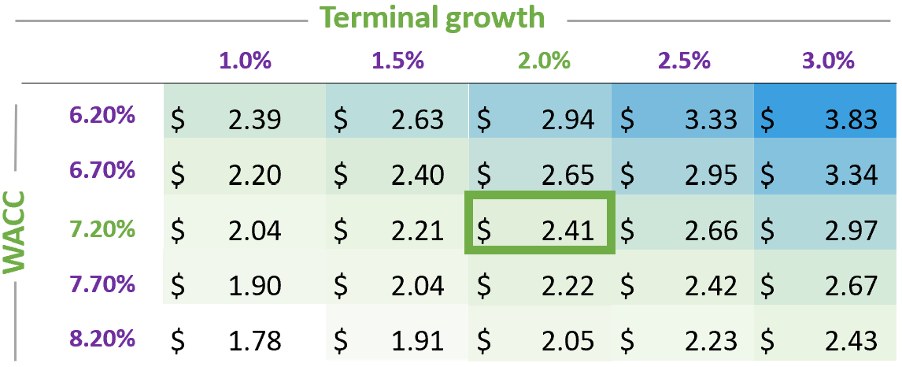

**FIGURE 19: IHH IS UNDERVALUED RELATIVE TO ITS PEERS**

Source: Bloomberg, Team Consensus

Source: Team Consensus

**RELATIVE VALUATION USING P/E AND EV/EBITDA**

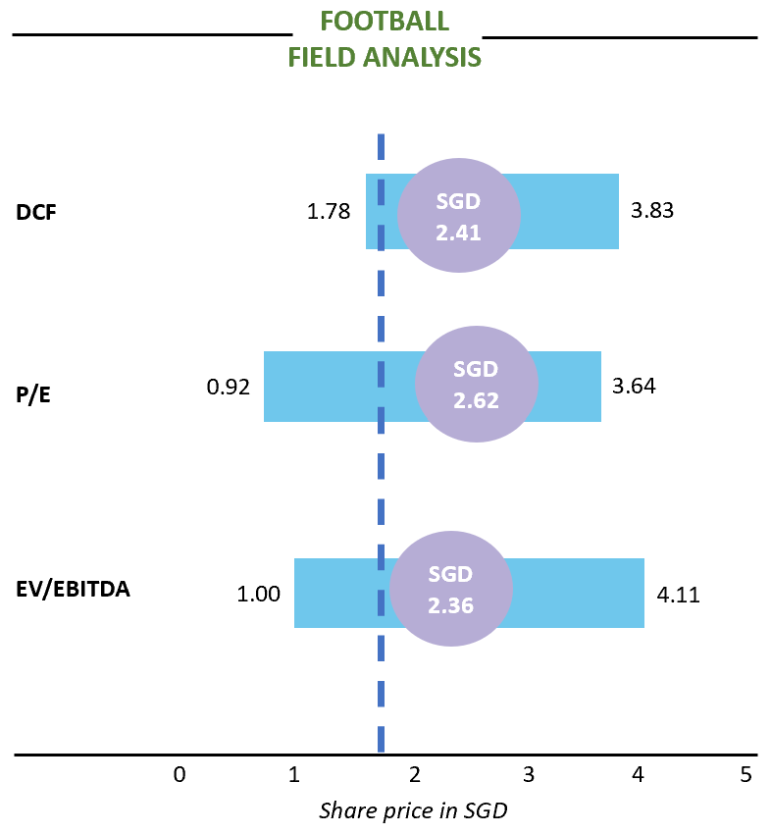Using a basket of 5 peers in the hospital and healthcare facility industry with leading market shares in their respective operating regions, as well as market capitalizations similar to IHH, the average P/E ratio and EV/EBITDA ratio among IHH’s peers is calculated. The P/E ratio is used to compare the relative stock price of IHH to its peers for every dollar of earnings. Given IHH's significant depreciation charges, we also adopt EV/EBITDA as a benchmark to compare IHH to its peers. In our football field analysis comprising of the DCF valuation, the P/E relative valuation, and the EV/EBITDA relative valuation, we observe that both the P/E and EV/EBITDA target price are similar to our DCF target price, at SGD 2.62 and SGD 2.36 respectively, implying that IHH is undervalued compared to its peers, despite its leading market share in Singapore, and second biggest market share in Malaysia, India, and Turkey. Therefore, we continue to adopt the target price from our DCF valuation and reiterate our BUY call for IHH at the target price of SGD 2.41.

**INVESTMENT RISKS**

**MARKET RISK | FOREIGN EXCHANGE RISK**

More than 70% of IHH’s revenue is denominated in non-Malaysian Ringgit terms. This exposes IHH to forex risks, especially from the Lira and to a lesser extent the Rupee.

**Mitigation**: 1) We note that IHH has reacted to the extraordinary depreciation of the Lira by hedging all non-lira denominated debts with cross-currency swaps up to their maturity dates. 2) They have also reduced exposure to the Lira through the expansion of European operations, increasing non-lira revenue s to 46% of European operations in 2022 from 36% in 2017. 3) They have reduced Euro-denominated debt from EUR267mn to EUR37mn from 2019 to 2020. Lira denominated revenues now account for about 10% of the group’s revenues, limiting potential fall in group revenues to 1% for every 10% depreciation of the Lira. Moreover, we expect continued expansion out of turkey to reduce revenue contribution from turkey, reducing the impact on group revenues by further depreciation of the Lira. 4) We note that interest and operational expenses for Indian operations are mostly denominated in Rupee. Along with the group’s diversified income streams, this limits the risk that IHH is exposed to, as a depreciation of the Rupee would not compress net income margins significantly.

**MARKET RISK | PERSISTING LABOR SHORTAGE COULD HINDER REVENUE GROWTH**

Nurses are in an acute shortage now due to the high attrition rate during covid. While we expect the nurse shortage to decrease, there is a risk that it may remain high, preventing IHH from opening more operational beds to service increased number of patients.

**Mitigation**: 1) IHH has put in place measures to increase the number of nurses by a few hundred over the next 6 months, supported by an accelerated hiring and administrative pipeline. 2) IHH has reduced the workload on nurses via technological automation and handing over tasks not requiring a nursing license to dedicated admins and general patient care staff. We expect this to increase nurse productivity and allow servicing of more beds. 3) The gradual reduction in covid cases also decreases the extraordinary workload on nurses. We anticipate nurse attrition rates to reduce correspondingly, easing the shortage of nurses.

**OPERATIONAL RISK | EXECUTION**

Key growth theses mentioned depend on management’s ability to execute accordingly to their strategic acquisition plan. Should management choose to deviate from this plan, ROE growth may not materialize.

**Mitigation**: While IHH’s management has had a past record of acquiring and building hospitals in new and uncertain markets, we note that IHH is currently in the process of divesting those underperforming assets under new management since 2019. Focused on improving ROE, we anticipate the possibility of the new management deviating from its strategy to be unlikely.

**ESG**

IHH consistently performs better than its peers on ESG according to benchmarks and we expect this to be the case going forward because of its ability to come up with innovative solutions to best serve its customers and its ability to ensure it provides the best healthcare treatments.

***FIGURE 24: IHH BEATS PEERS IN OVERALL ESG RATINGS***

|  |  |  |  |  |  |
| --- | --- | --- | --- | --- | --- |
| IHH | Relative | Raffles medical | KPJ healthcare | Bangkok Chain | Chularat Hospital |
| 1st | Better than most | 3rd | 1st Tied | 4th | 2nd |

*Source: Refinitiv, Team Consensus*

**ENVIRONMENT**

Compared to its peers in the hospital and healthcare provider industry, IHH is more efficient in its energy usage, having a lower total energy used per million in revenue (Figure 21). We believe that their more efficient energy usage not only reduces the impact of the environment due to carbon emissions, but also using energy more efficiently lowers energy costs and enables IHH’s bottom line to be less susceptible to fluctuations in energy prices. On waste management, IHH produces lower total waste per million in revenue than most of its peers (Figure 22) and produces less hazardous waste than most of its peers, even smaller hospital chains such as Chularat Hospital PCL in Thailand. This is a positive for IHH because they use their resources more efficiently and can spend less on waste disposal services. However, IHH recycles a smaller proportion of its total waste than its peers (Figure 23). We suggest that IHH ramp up its recycling efforts to be more environmentally friendly and attract investors who are more environmentally conscious.

**SOCIAL**

Socially, IHH fares better than its peers. We believe this is so, as IHH can serve its customers well by ensuring that their healthcare services have clear cost-transparency as well as improving its operations through digitalisation efforts.

***FIGURE 25: IHH BEATS PEERS SOCIALLY***

|  |  |  |  |  |  |
| --- | --- | --- | --- | --- | --- |
| IHH | Relative | Raffles medical | KPJ healthcare | Bangkok Chain | Chularat Hospitals |
| 1st | Better than most | 2nd | 1st Tied | 4th | 3rd |

*Source: Refinitiv, Team Consensus*

Through its Value Driven Outcomes (VDO) initiative, IHH has become better at identifying and predicting the cost of healthcare for customers. VDO has already been implemented across Singapore, Malaysia, Turkey, Brunei, and Hong Kong. Moreover, using artificial intelligence (AI), IHH can analyse a patient’s particular condition and profile to determine bills with approximately 80% accuracy in Singapore and Hong Kong. With these measures, IHH can give its patients a clearer idea of what they might expect the price of their healthcare treatment to amount to. We believe that this will increase patient confidence and trust in IHH’s hospitals.

In addition, since the start of the COVID-19 pandemic, IHH hospitals have been aiding in the fight against COVID-19 in all its operating regions, helping to reduce and share the burden on the public healthcare system (Appendix 10). IHH engaged widely in community testing, subsidised medical treatments, and loaned equipment to public hospitals, amongst many other efforts. IHH’s ability to form partnerships with the public sector in times of crisis not only heightens the company’s reputation among the public, but also can serve as a source of revenue for the group, as was the case in 2020 and 2021.

IHH recognises that there is increasing burnout as nurses are overworked, especially due to COVID-19 in the past 3 years. As a result, more medical staff leaving the organisation, as shown by the decrease in both the new hires rate (Figure 26).

To mitigate this, IHH has implemented its Cerebral Plus (C+) project that allows patients to book appointments and view medical results electronically. This frees up administrative tasks from healthcare staff. Additionally, it has also introduced Patient Care Associates to help nurses with tasks that do not require a nursing license. This reduces the workload on nurses in IHH. More importantly, IHH also conducts annual benchmarking against key industry players to ensure that employees are fairly compensated and have ample career development opportunities. We believe that this is illustrated by the decrease in turnover rate in 2020 (Figure 26). While increases wages for employees will increase costs, we believe that this is offset by the potential high hiring and training costs that would be incurred if the existing workforce is not retained. Therefore, by focusing on the well-being and fair remuneration of its employees, we believe that IHH will benefit in the long run.

In conclusion, we believe that socially IHH fairs well socially. This is because 1) IHH best serves its customers well by providing greater cost-transparency in its healthcare, 2) has strong partnerships with the public healthcare systems, aiding in times of crises, and 3) practices fair remuneration of employees and engages in efforts to reduce burnout amongst employees.

**GOVERNANCE**

IHH’s achieves a better score compared to peers in governance. This evaluation is based on 2 factors: the Board of Directors and the groups’ shareholder structure.

***FIGURE 27: IHH BEATS PEERS IN GOVERNANCE***

|  |  |  |  |  |  |
| --- | --- | --- | --- | --- | --- |
| IHH | Relative | Raffles medical | KPJ healthcare | Bangkok Chain | Chularat Hospitals |
| 1st | Better than most | 4th | 2nd | 5th | 3rd |

*Source: Refinitiv, Team Consensus*

**Board of Directors**. IHH’s 13-member board of directors come from diversified fields that help the group for the future. Members have historically been active in board discussions as seen by the 100% attendance for the board meetings in 2021. IHH aims to achieve a 50:50 ratio in male to female in leadership roles by 2025. Given only 23.1% of its board members are female, we suggest that equal representation is reflected in the board as well.

The board comprises of various nationalities such as: Singaporean, Malaysian, Japanese, Turkish, Australian. We believe this will add a global perspective to major decisions by management. This is important as IHH operates on a global scale. The board comprises of 5 Independent Non-Executive Directors, 5 Non-Independent Non-Executive directors, 1 Non-Independent Executive Director and 2 Alternate Directors. Hence, Independent Non-Executive members made up 45% of the Board Composition, which we believe promotes fair and unbiased decision making. IHH’s aims to have a greater proportion of independent directors in the future, which we also see as a positive.

**Shareholders**: The largest shareholders in the company include established Japanese conglomerate Mitsui & Co Ltd and Malaysian sovereign wealth fund Khanazah Nasional. Having established entities as majority shareholders allows IHH to gain a positive reputation amongst other investors. IHH board members Mr Takeshi Akutsu, Mr Takeshi Saito, Mr Tomo Nagahiro and Mr Satoshi Tanaka represent Mitsui & Co Ltd and Mr Tan Sri Mohammed Azlan bin Hashim, Mdm Mok Jia Mei, Dr Farid bin Mohamed Sani represent Khazanah Nasional. We note that board members appointed by the two entities do not have ownership of IHH and we suggest that they increase their stakes in the company to better align the board’s interest with shareholders.

Lastly, IHH has a dividend policy whereby at least 20% of the Group's net income shall be distributed to shareholders. As such, we believe that shareholders will continue to be fairly rewarded when IHH performs well.

In conclusion, we view the large institutional shareholders and international make-up of the board to enable the company to make well-informed decisions, resulting in a good governance score looking forward.

**APPENDIX 1:**

**IHH THE LEADER IN PURCHASES OF ADVANCED MEDICAL EQUIPMENT**

|  |  |  |
| --- | --- | --- |
| Medical Tech | Region | Better Outcomes Compared to Legacy Equipment |
| Proton Therapy | First in SEA | * Precise targeting of cancer * Minimizing radiation to vital organs * Helping to avoid more radiation to areas that previously had radiation |
| MRIdian | First in Turkey | * Enhance real time tumour visualization. * Few treatments sessions * Minimal side effect |
| Gamma Knife | Malaysia | * Extreme precision * No incision * Painless |
| Linear Accelerator | Malaysia | * Reach very high energies without need of high voltage. * High Accuracy treatment * Reduce time required for radiological therapy. |

*Source: RMGK, PR Newswire, Company Data*

**APPENDIX 2:**

*Source: KPJ, IHH & BDMS Company Data*

**APPENDIX 3:**

**VARIOUS ADVANCED TREATMENTS AVAILABLE AT TERTIARY HOSPITALS**

|  |  |  |
| --- | --- | --- |
| Type of Illness | Tertiary Care Treatment | Specialized Service |
| Complex surgeries | Organ transplants, neurosurgeries, reconstructive surgeries | Transplant Center, Neurosurgical Center |
| Specialized cancer treatments | Radiation therapy, chemotherapy | Cancer Center |
| Cardiovascular treatments | Angioplasty, bypass surgery | Cardiac Center |
| Neonatal intensive care | Premature or critically ill newborns | Neonatal Intensive Care Unit |
| Palliative care | Individuals with chronic illnesses or end-of-life care | Palliative Care Unit |
| Intensive care | Patients with severe injuries or illnesses | Intensive Care Unit |
| Trauma care and burn treatment | Trauma and burn management | Trauma Center, Burn Center |
| Genetic counseling and treatment | Genetic counselling and therapy | Genetic counseling center |
| Neurological and neurosurgical treatments | Advanced neurological and neurosurgical treatments | Neurological Center, Neurosurgical Center |

*Source: verywellheatlh.com*

**APPENDIX 4:**

**GOVERNMENTS IN OPERATING REGIONS HAVE PUSHED FOR INCREASED PREVENTATIVE HEALTHCARE**

|  |  |
| --- | --- |
| Region | Initiative |
| India | * Preventive Care packages: Regular check-ups and dietary consultations with doctors * National AIDS Control Programme (NACP) |
| Malaysia | * National Strategic Plan for Tobacco Control (2015-2020) * National Strategic Plan for Active Living (2016-2025): to prevent and control non-communicable diseases (NCDs). |
| Turkey | * Building more health centres, training more family physicians, and promoting telemedicine services. * campaigns to raise awareness about healthy lifestyles and preventative measures. |
| Central Eastern Europe | * Immunization programs: Protecting individuals from infectious diseases. * Screening programs: to detect diseases in early stages * Healthy lifestyle promotion: to encourage healthy lifestyle choices and education. |
| Singapore | * Community Health Assist Scheme (CHAS) enables all Singapore Citizens to receive subsidies for medical and/or dental care at participating General Practitioner (GP) and dental clinics. * Healthier SG plan: shift in emphasis from reactive caring for those already unwell to proactively preventing individuals from falling ill. |

*Source: Government Data*

**APPENDIX 5:**

**BRAIN DRAIN IN BULGARIA, SERBIA & MACEDONIA**

|  |  |
| --- | --- |
| Country | Outflow of medical talent |
| Bulgaria | * Every year Bulgaria loses between 500 and 600 doctors to emigration |
| Serbia | * Country lacks 13000 medical workers in various areas. |
| Macedonia | * Estimated that 1200 doctors left the country between the period from 2010 and 2018 * Around 300 medics leave Macedonia every year. |

*Source: Aljazeera, obserwatorfinansowy, China-IEE institute*

**APPENDIX 6:**

**INADEQUATE PUBLIC HEALTHCARE SYSTEMS IN BULGARIA, SERBIA & MACEDONIA**

|  |  |  |  |  |  |  |
| --- | --- | --- | --- | --- | --- | --- |
| Country | Low wages | Poor working conditions | Underfunded | Outdated equipment | Unpredictable career development | Harassment |
| Bulgaria | Tick with solid fill | Tick with solid fill | Tick with solid fill | Tick with solid fill | Tick with solid fill |  |
| Serbia | Tick with solid fill | Tick with solid fill |  | Tick with solid fill |  |  |
| Macedonia | Tick with solid fill | Tick with solid fill | Tick with solid fill |  |  | Tick with solid fill |

*Source: Aljazeera, Obserwator Finansowy, China-IEE institute*

**APPENDIX 7:**

|  |  |  |  |  |  |
| --- | --- | --- | --- | --- | --- |
| Treatment Name | Raffles Hospital | Gleneagles  Hospital | Mount Elizabeth Novena Hospital | Parkway East Hospital | Mount Elizabeth Hospital |
| Colonoscopy | $2,248 | $2,725 | $3,038 | $3,377 | $2,725 |
| Nasoendoscopy | $6,932 | $10,265 | $8,651 | $8,849 | $6,926 |
| Breast, Various Lesions (Day Surgery) | $2,510 | $2,710 | $3,849 | Na | $3,469 |
| Intestine/Stomach (Day Surgery) | $3,080 | $3,210 | $3,215 | $3,400 | $2,982 |
| Hemorrrhoids (Day Surgery) | $7,844 | $8,210 | $9,209 | Na | $7,655 |
| Fibreoptic with Removal of Polyp (Day Surgery) | $3,210 | $3,571 | $3,837 | $4,143 | $3,416 |
| Gallbladder surgery (1 bedded ward) | $19,650 | $20,419 | $20,266 | $17,301 | $19,390 |

**RMG TYPICALLY PROVIDES CHEAPER TREATMENT THAN IHH**

*Source: Ministry of Health, Singapore*

**APPENDIX 8:**

**APPENDIX 9:**

**IHH DRIVING ROE TO WEIGHTED INDUSTRY AVERAGE**

|  |  |  |  |
| --- | --- | --- | --- |
| **Operating region​** | **EBITDA contribution to group​** | **Average ROE for hospitals industry​** | **Region sampled​** |
| Singapore​ | 40%​ | 15.65%​ | Global​ |
| Malaysia & CEE​ | 46%​ | 10.79%​ | Emerging markets​ |
| India​ | 16%​ | 14.03%​ | India​ |
| **Total**​ | **102%**​ | **13.20%**​ | ​NA |

*Source: Damodaran*

*Total EBITDA contribution from the 3 main operating regions is 102% due to negative, but minimal, EBITDA*

*contribution from other operating regions. The weighted ROE average has been scaled to 100%.*

|  |  |
| --- | --- |
| Country | Activities |
| Malaysia | * Allocated 200 beds to treat non-Covid 19 patients transferred from public hospitals. * Pledged >RM24m to subsidise the medical treatment of patients going to public hospitals * Loaned out 20 ventilators to public hospitals * Facilitated the mobilisation of an experienced infectious disease physician to support MOH in managing the covid-19 outbreak in the state of Sabah. This physician has been selected as the technical member in the Government assessment programme for a Covid vaccine and is the only member from a hospital in the National Covid vaccine committee. * Collaborated with MOH to increase the testing capacity for Covid-19 |
| Singapore | * Accepted stable and recovering Covid-19 patients from public health hospitals. Singapore has admitted and discharged > 350 patients. * Conduct swab testing for more than 11500 people in dormitories, polyclinics, and other locations. Also operate temporary testing centres for a month. * Parkway Pantai was the first private hospital in Singapore to provide Covid-19 polymerase chain reaction (PCR) testing. |
| Turkey &  CEE | * All Acibadem hospitals in Turkey have been declared “Pandemic Hospitals” by government decree and have designated wards for Covid-19 patients and persons under investigation. |
| Hong Kong | * On 1 September 2020, the government of Hong Kong set up its Universal Community Testing Programme, with 141 testing centres across the 18 districts. IHH volunteered its services at the Wong Chuk Hang Covid-19 testing centre which offers free Covid-19 swab tests to all Hong Kong residents. |

**APPENDIX 10:**

**IHH AIDING IN COVID-19 RELIEF EFFORT IN ITS OPERATING REGIONS**

*Source: Aljazeera, Obserwator Finansowy, China-IEE institute*

**APPENDIX 11:**

**REFERENCES**

Acibadem. n.d. “MRIdian - ViewRay - Acıbadem Healthcare Services.” Acıbadem Healthcare Group. Accessed January 30, 2023. https://acibademinternational.com/technology/mridian-viewray/.

BDMS. 2015. “The Acquisition of Muangraj Hospital.” Bangkok Dusit Medical Services (BDMS). https://bdms.listedcompany.com/misc/PRESN/20150702-bgh-muangraj.pdf.

BDMS. 2022. “December 2022 Bangkok Dusit Medical Services (BDMS) Investor Presentation 3Q22 & 9M22 Results.” Bangkok Dusit Medical Services (BDMS). https://bdms.listedcompany.com/misc/PRESN/20221221-bdms-investor-presentation-3q2022.pdf.

BDMS. 2022. “December 2022 Bangkok Dusit Medical Services (BDMS) Investor Presentation 3Q22 & 9M22 Results.” Bangkok Dusit Medical Services (BDMS). https://bdms.listedcompany.com/misc/PRESN/20221221-bdms-investor-presentation-3q2022.pdf.

CCW Global. 2015. “Waiting List for Specialist Care in Hong Kong's Public System Over….” CCW Global. https://hk.ccw-global.com/news/waiting-list-for-specialist-care-in-hong-kongs-public-system-over-100-weeks.

China-CEE Institute. 2021. “North Macedonia social briefing: The impact of immigration and population change on the economic and social development in N.Macedonia – China-CEE Institute.” China-CEE Institute. https://china-cee.eu/2021/10/28/north-macedonia-social-briefing-the-impact-of-immigration-and-population-change-on-the-economic-and-social-development-in-n-macedonia/.

Damodaran, Aswath. 2023. “Return on Equity by Sector (US).” NYU Stern. https://pages.stern.nyu.edu/~adamodar/New_Home_Page/datafile/roe.html.

Damodaran, Aswath. 2023. “Country Default Spreads and Risk Premiums.” NYU Stern. https://pages.stern.nyu.edu/~adamodar/New_Home_Page/datafile/ctryprem.html.

Dimitrievska, Valentina. 2019. “Violence against doctors escalates in North Macedonia’s neglected health service.” bne IntelliNews. https://www.intellinews.com/violence-against-doctors-escalates-in-north-macedonia-s-neglected-health-service-168755/.

eurostat. 2022. “Healthcare expenditure statistics - Statistics Explained.” European Commission. https://ec.europa.eu/eurostat/statistics-explained/index.php?title=Healthcare_expenditure_statistics#Healthcare_expenditure.

Fact.MR. 28. “Malaysia Medical Tourism Market Forecast Report 2021-2028.” Fact.MR. https://www.factmr.com/report/malaysia-medical-tourism-market.

GlobalData. 2021. “Household Consumption Expenditure on Health per Household in Turkey (2010 - 2020, $).” GlobalData. https://www.globaldata.com/data-insights/macroeconomic/household-consumption-expenditure-on-health-per-household-in-turkey-2096542/.

GlobalData. 2021. “Household Consumption Expenditure on Health per Household in the Netherlands (2010 - 2020, $).” GlobalData. https://www.globaldata.com/data-insights/macroeconomic/household-consumption-expenditure-on-health-per-household-in-the-netherlands-2096544/.

Harper, Jo. 2016. “Serbia experiencing health sector brain drain.” Obserwator Finansowy. https://www.obserwatorfinansowy.pl/in-english/serbia-experiencing-health-sector-brain-drain/.

“IHH Annual Report 2021.” 2021. IHH healthcare. https://www.ihhhealthcare.com/docs.htm?filepath=IHH/IHH%20Annual%20Report%202021%20a.pdf.

Jana, Arup, and Aparajita Chattopadhyay. 2022. “Prevalence and potential determinants of chronic disease among elderly in India: Rural-urban perspectives.” NCBI. https://www.ncbi.nlm.nih.gov/pmc/articles/PMC8916671/.

Knoema. 2021. “Serbia Health expenditure as a share of GDP, 1960-2022 - knoema.com.” Knoema. https://knoema.com/atlas/Serbia/topics/Health/Health-Expenditure/Health-expenditure-as-a-share-of-GDP.

KPJ Healthcare. 2022. “Delivering What Matters to You.” KPJ Healthcare. https://kpj.listedcompany.com/misc/ar2021/KPJ_IR.pdf.

Macrotrends. 2019. “Bulgaria Healthcare Spending 2000-2023 | MacroTrends.” Macrotrends. https://www.macrotrends.net/countries/BGR/bulgaria/healthcare-spending.

Mancheva, Gergana, and Diana Doncheva. 2022. “The shortage of doctors and young specialists is becoming a national problem for Bulgaria.” БНР. https://bnr.bg/en/post/101669305/the-shortage-of-doctors-and-young-specialist-is-becoming-a-national-problem-for-bulgaria.

Ministry of Health, Singapore. 2021. “News Highlights.” MOH | News Highlights. https://www.moh.gov.sg/news-highlights/details/average-waiting-time-for-outpatient-appointments-at-specialist-clinics-at-restructured-hospitals-in-each-month-of-2020.

Ministry of Health, Singapore. 2022. “Fee Benchmarks and Bill Amount Information Nose, scope (single or repeat, during 90-day period).” MOH | Fee Benchmarks and Bill Amount Information. https://www.moh.gov.sg/cost-financing/fee-benchmarks-and-bill-amount-information/DetailsByHospital/SM700N--1--Day---Surgery---(Subsidised).

New York University. 2023. “Ratings and Coverage Ratios.” NYU Stern. https://pages.stern.nyu.edu/~adamodar/New_Home_Page/datafile/ratings.html.

Pavel, Sadik. 2015. “Assessing willingness to pay for health care quality improvements - BMC Health Services Research.” BMC Health Services Research. https://bmchealthservres.biomedcentral.com/articles/10.1186/s12913-015-0678-6.

Petkova, Mariya, and Georgi Nikolov. 2014. “Bleeding doctors: Bulgaria’s medical crisis | Health.” Al Jazeera. https://www.aljazeera.com/features/2014/1/22/bleeding-doctors-bulgarias-medical-crisis.

Pillay, Datuk I., Roslan J. Ghazali, Noor Hazilah A. Manuf, Abu H. Abdullah, Azman A. Bakar, Faisal Salikin, Mathyvani Umapathy, Roslinah Ali, Noriah Bidin, and Wan I. Ismail. 2011. “Hospital waiting time: the forgotten premise of healthcare service delivery?” IIUM Repository (IRep). http://irep.iium.edu.my/8795/1/Hospital_waiting.pdf.

Public Health Department Ministry of Health Malaysia. 2016. “National Strategic Plan For Non-Communicable Disease.” Kementerian Kesihatan Malaysia. https://www.moh.gov.my/moh/resources/Penerbitan/Rujukan/NCD/National%20Strategic%20Plan/FINAL_NSPNCD.pdf.

Renub Research. 2022. “India Medical Tourism Market, Share, Forecast, Industry Trends, Size, Growth, Outlooks, Impact of COVID-19.” Wikipedia. https://www.researchandmarkets.com/reports/5654352/india-medical-tourism-market-share-forecast?utm_source=BW&utm_medium=PressRelease&utm_code=wfvtcc&utm_campaign=1780762+-+India+Medical+Tourism+Market+Analysis+Report+2022%3a+Share%2c+Forecasts%2c+Industry+.

Research and Markets. 2021. “Healthcare Providers in the Netherlands - Market Summary, Competitive Analysis and Forecast to 2025.” Research and Markets. https://www.researchandmarkets.com/reports/5350391/healthcare-providers-in-the-netherlands-market.

Rocky Mountain Gamma Knife Center. 2017. “Gamma Knife Benefits | Brain Tumor Treatment | Gamma Knife Surgery.” Rocky Mountain Gamma Knife Center. https://www.rmgk.com/benefits-of-gamma-knife.

Science and Technology Facilities Council. 2016. “https://www.isis.stfc.ac.uk/Pages/Particle-accelerators-Linear-accelerators.aspx.” ISIS Particle accelerators: Linear accelerators. https://www.isis.stfc.ac.uk/Pages/Particle-accelerators-Linear-accelerators.aspx.

Sharma, Dinesh C. 2015. “India still struggles with rural doctor shortages.” The Lancet. https://www.thelancet.com/journals/lancet/article/PIIS0140-6736(15)01231-3/fulltext.

The Silver Book. 2009. “Percentage of the Population With Chronic Diseases, 1995-2030.” Silver Book. https://www.silverbook.org/fact/percentage-of-the-population-with-chronic-diseases-1995-2030/.

The Star. 2022. “IHH likely to shine in medical tourism.” The Star. https://www.thestar.com.my/business/business-news/2022/09/21/ihh-likely-to-shine-in-medical-tourism.

statista. 2020. “Health Care - Eastern Europe.” Statista. https://www.statista.com/outlook/dmo/ecommerce/beauty-health-personal-household-care/health-care/eastern-europe.

TechSci Research. 2022. “Turkey Medical Tourism Market Size, Trends, Growth, Forecast, 2027.” TechSci Research. https://www.techsciresearch.com/report/turkey-medical-tourism-market/9418.html.

TodayOnline. 2022. “Close to 4000 new nurses to be added to Singapore workforce by end of 2023: Ong Ye Kung.” TODAY. https://www.todayonline.com/singapore/close-4000-new-nurses-be-added-singapore-workforce-end-2023-ong-ye-kung-2052406.

Torrey, Trisha. 2022. “Differences Between Primary, Secondary, Tertiary, and Quaternary Care.” Verywell Health. https://www.verywellhealth.com/primary-secondary-tertiary-and-quaternary-care-2615354.

Tripkovic, Katica, Milenaa Santric-Milicevic, Milena Vasic, Mirjana Z. Sulovic, Marina Odalovic, Vesna M. Jovanovic, and Zoran Bukumiric. 2021. “Factors Associated with Intention of Serbian Public Health Workers to Leave the Job: A Cross-Sectional, Population-Based Study.” NCBI. https://www.ncbi.nlm.nih.gov/pmc/articles/PMC8535250/.

ViewRay, Inc. 2022. “Acibadem Group Purchases Second MRIdian® System for Acibadem Altunizade Hospital in Istanbul.” PR Newswire. https://www.prnewswire.com/news-releases/acibadem-group-purchases-second-mridian-system-for-acibadem-altunizade-hospital-in-istanbul-301494723.html.

Wattanosoth Cancer Hospital. 2018. “Linear Accelerator (LINAC).” Linear Accelerator (LINAC) | Wattanosoth Cancer Hospital. https://www.wattanosothcancerhospital.com/en/our-technologies/linear-accelerator-linac.

Watts, Kerean. 2019. “India's shortage of specialist doctors is still staggering.” Health Issues India. https://healthissuesindia.com/2019/07/02/indias-shortage-of-specialist-doctors-is-still-staggering/.

The World Bank. 2022. “Doctor to patient ratio.” World Bank Open Data | Data. https://data.worldbank.org/.